BENDING LOSS
Objective: The objective of this experiment is to study bending loss.

List of Equipment:
- Optical fiber kit
- Function generator
- Optical fiber of different length

Theory:
When ever the condition for angle of incidence of the incident light is violated the losses are introduced due to refraction of light. This occurs when fiber is subjected to bending. Lower the radius of curvature more is the loss.

Procedure:
- Connect function generator square wave output to LED (emitter).
- Connect optical fiber between LED output and PIN (detector) input. An oscilloscope is connected to PIN (detector) output.
- Select the number of turn by clicking the options given. First click “1 Turn optical fiber” button.
- Click run continuously button to run the experiment.
- The received signal can be seen in the oscilloscope. Measure the amplitude of the received signal and name it V₁.
- Then change the number of turns to 2 by clicking the option “2 turn optical fiber”.
- Measure the amplitude of the received signal by oscilloscope and name it V₂.
- Compare the value obtained previously with the latest one. It can be seen easily that due to bends, loss occurs in the cable.
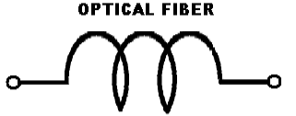
Light Emitting Device
Light Receiving Device
Electrical signal out
Electrical signal in
Discussions:
- Explain through sketch how bending loss occur?
- How is micro bending losses reduced?
References:
- Gerd Keiser, Optical Fiber Communications, Tata McGraw Hill, 2008.

